SANITARY VALVE TIMING – FEATURES

This valve is designed and continuously tested 3 years and has demonstrated excellent performance:

- Before use, the cistern is empty, so there is no "loss" in the passive phase of the "waiting" on the active work
- Activated on today known way (pulling the lever cistern)
- No dew point, because the cistern is empty
- No beep (sounds uncomfortable)
- Use the pressure from 0.2 to 10 bar
- The required capacity of the active volume can be regulated and it is always constant regardless of changes of pressure in the mains and is selected by the 3, 4, 6, 9 or 12 liters per flush (in the USA goes up to 4.5 gallons which is 17 gallons )
- Ative charging time ranges from 8 to 15 seconds, which depends on the pressure in the mains
- Operates without additional energy
- It is made entirely of plastic
- It is suitable for the use of public toilets, sanitation, surgical room as well as nutrition
- Can be installed as the first installation or other installation in all existing cistern

1ST ALTERNATIVE
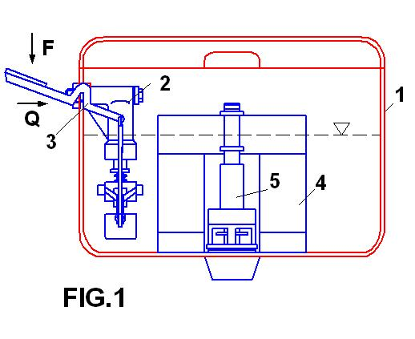
Figure 1 shows a standard toilet tank, which is marked with red color. It is mounted on a new set of toilets in different variants of installation. Figure 1 shows that the sanitary inlet valve 2 is mounted sideways on 1 wall of the court, and on the same side can mount and knobs 3 There is a variant of the mounting arm 3, and on the other side of the set of valves. The Centre Court 1 is mounted on a central set of 5 with float 4. With a picture that is very simple assembly, and that anyone can do.

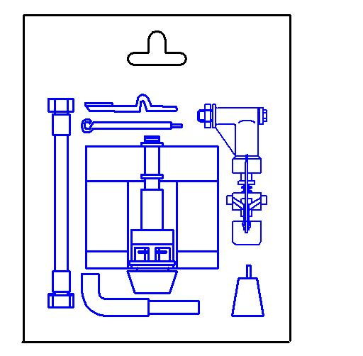
In Figure 2 shows the method of delivery. With sales in the form of vacuum-packed set, which razmontira and specifying the number of assembly is done. The explanation given is mounting on the back of the set. In another set of installation have been given a variety of mounting options for low and high mount. All programs will be drawn up in plastic. A constructive solution set is further mounted such that it will have a very long lifespan, so there will be no problem concerning guarantees.

FIG. 2

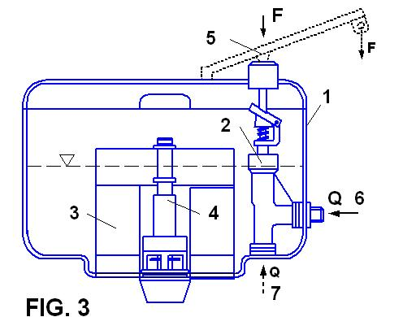
2ND ALTERNATIVE
Figure 3 shows a variant of the first mounting assembly. From Figure 3 shows that the additional cistern formed so that it can be mounted sideways off the water supply on both sides to position 6 and on the underside of the 7 position. It can also be set low mounting option, so that the activation is performed directly on the lever valve 2 first installation. If you are going to install a high, then add 5 to gear to be activated by pulling the chains down. In this pot, does not matter whether the installation is performed on the right or left side. This program contains 90% more positions depending on the image 1. These cisterns will be done in transparent plastic.

